Module 3.2 Assignment
“Normalized Tables”
Andres Chavarria
11/02/26

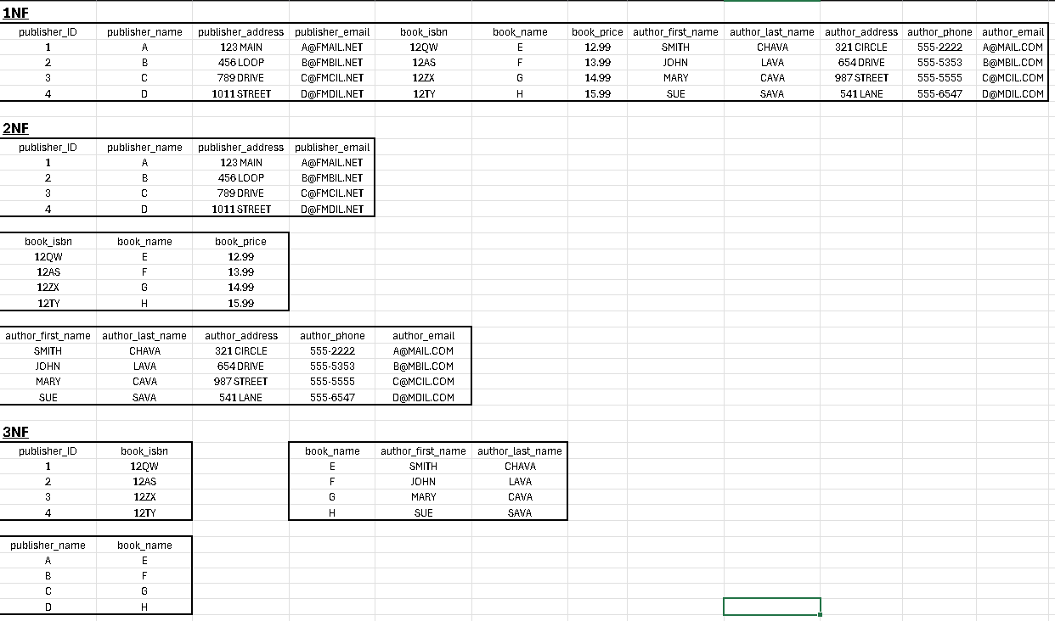
Excel Snippet:

